1. Create a student table with the student id, name, and marks as attributes where the student id is the primary key.

**create table student(studentid int primary key ,studname varchar(20),marks decimal);**

2. Insert the details of a new student in the above table

**Insert into student**

**Values (1,'roshin', 87.5),**

**(2,'chaitu', 68.0),**

**(3,'arshu', 89.5),**

**(4,'arman', 75.6),**

**(5,'rose', 95.2),**

**(6,'aruvi', 58.0),**

**(7,'seema', 45.6),**

**(8,'preksha', 36.9),**

**(9,'rahul', 50.9);**

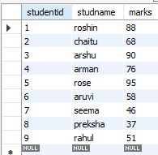

3. Delete the detail of a student in the above table.

**Delete from student where studentid=5;**

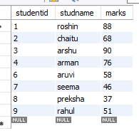

4. Insert more records to the above student table more than 7.

**Insert into student**

**Values (5,'rose', 95.2),(11,'priya',38.5),(12,'ruby',66.4),(13,'mokshi',53.5),**

**(14,'deepu', 77.5),(15,'tarun','90.1');**

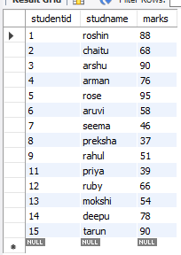

5. Use the select command to get the details of the students with marks more than 80.

**SELECT studentid, name, marks FROM student**

**WHERE MARKS >80;**

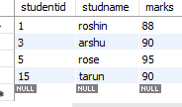

6. Find the min, max, sum, and average of the marks in a student marks table.

**select max(marks), min(marks), sum(marks) , avg(marks) from student;**

C:\Users\vasan\OneDrive\Desktop\ma.PNG

7. Find the student names whose marks are greater than 60 and less than 40.

**SELECT studname, marks FROM student**

**WHERE marks > 40 AND marks <60;**

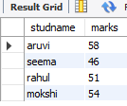

8. Write a SQL query to order the (student ID, marks) table in descending order of the marks

**SELECT studentid, marks FROM student**

**ORDER BY marks desc;**

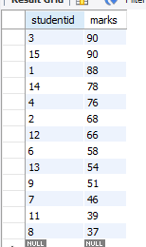

9. Write a SQL query to display the marks without decimal places, display the remainder after dividing marks by 3 and display the square of marks

**select round(marks,2),mod(marks,3),pow(marks,2) from student;**

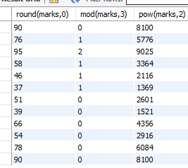

10. Write a SQL query to display names into capital letters, small letters, display first 3 letters of name, display last 3 letters of name, display the position the letter A in name

**select ucase(name),lcase(name),left(name,3),right(name,3),**

**instr(name,'a') from student;**

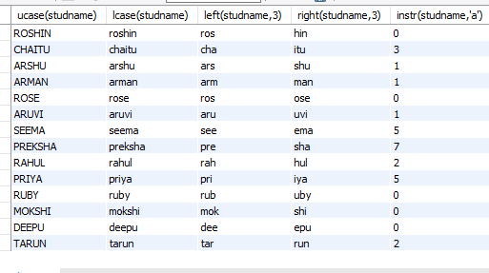

**Additional Questions :**

1. Remove extra spaces from left, right and both sides from the text –” Innomatics Research Lab “.

**Select ltrim("Innomatics Research Lab ")as "Left trim", rtrim("Innomatics Research Lab ") as "Right trim",**

**trim("Innomatics Research Lab ") as ‘trim’;**

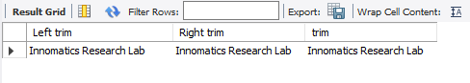

1. Display today’s date in “Date/Month/Year” format

**select concat(date(now()),concat("/",concat(month(now()),concat("/",year(now())))));**

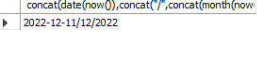

1. Display dayname, monthname, day, dayname, day of month, day of year for today’s date.

select **dayname(now()),monthname(now()),day(now()),dayname(now()),dayofmonth(now()),dayofyear(now(),date(now()));**

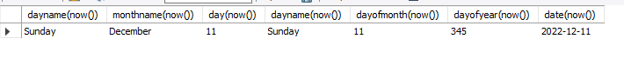

1. Explain the difference between primary key and foreign key.

**PRIMARY KEY:**

It is uniquely identify each row in a table.

–it cannot accept null values

--each table can have only one primary key

--it can be created on auto increment field (identity column).

**FOREIGN KEY:**

It is a field in one table that refers to the primary key in another table.

-- It can contain duplicate values

-- A table can contain more than one foreign key -- it can accept null values.